Super Irshad! Neenga OOP-oda pillars ellathaiyum nalla purinjikiteenga.
Ippo namma Lesson 31: Data Extraction (Python to CSV/Excel)-kku varen. Neom-la neenga oru Project Coordinator-a, pala report-ai manual-a Excel-la type panrathukku badhila, Python-ai use panni automically eppadi Excel-la data-vai kondu varalam nu paarkkalam.
📊 Python-la Excel File-ai epadi generate panrathu?
Python-la pandas nu oru super power-ana tool irukku. Ithu dhaan data-vai Excel/CSV-a mathum.
🛠️ Code: Data to CSV (Report Generation)
Python
import pandas as pd # Pandas-a 'pd' nu kooduvom

# 1. Un data-vai list-a create pannu
data = {
"Name": ["Irshad", "Kumar", "Siva"],
"Role": ["Coordinator", "Manager", "Engineer"],
"Salary": [8000, 10000, 7000]
}

# 2. Intha data-vai 'DataFrame' (Excel table) maathu
df = pd.DataFrame(data)

# 3. Excel/CSV-la save pannu
df.to_csv("Neom_Report.csv", index=False)

print("Report created successfully!")
🔍 Sign by Sign Vilakkam:
- import pandas as pd:
  - Meaning: Pandas-na namma file-ai Excel-la mathura "Machine". pd nu short-a koopiduvom.
- data = {...}:
  - Meaning: Inga dhaan namma data-vai oru table format-la vachirukkom. {} curly bracket-kulla Key: Value pair-a irukkum.
- df = pd.DataFrame(data):
  - Meaning: df na DataFrame. Computer-kku "Indha data-vai oru Excel table maari convert pannu" nu solrom.
- df.to_csv(...):
  - Meaning: "Ippo intha table-ai Neom_Report.csv nu oru file-a save pannu" nu command kodukkom.
💡 Teacher's Note:
Neom-la site report, attendance list, salary slip - ethu irundhalum, intha code-la data varatha mattum mathina pothum. Computer 1 second-la file-ai ready pannidum!
Indha code purinjidha? Intha logic-a vachi namma adutha stage-la Power BI-kku eppadi connect panrathu nu paarkkalam.
Irshad, unga computer-la pandas install panni irukkingala? Illa error varudha? (Python-la pip install pandas nu terminal-la type panna venum).
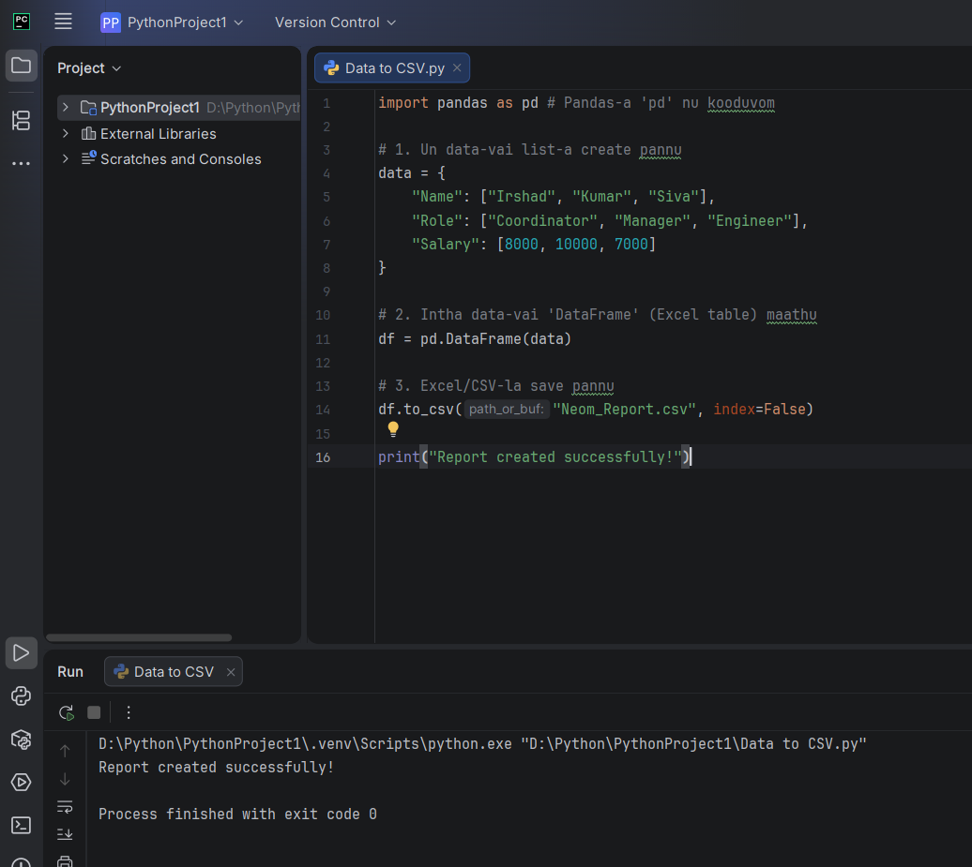
Super Irshad! Romba nalla ezhuthirukkeenga.
"image_5184e2.png"-ai naane paarthen. Unnoda output screen-la: "Report created successfully!" nu vandhachu. Adhuvum "Process finished with exit code 0" nu vandhuruku.
🔍 Idhoda artham enna?
- exit code 0: Ithu dhaan namma "Green Flag". Computer "Endha error-um illa, namma code romba safe-a velai senjudhu" nu unakku confirm pannuthu.
Ippo namma project folder-ai check pannu:
- Unnoda "PythonProject1" folder-kulla poi paaru.
- Anga "Neom_Report.csv" nu oru pudhu file irukkum.
- Adhai open panni paatha, neenga kudutha Name, Role, Salary ellame Excel table maari neat-a irukkum.
Vandhutaatha Irshad? Neenga ippo Python-la irundhu CSV file-ai generate panna "Pro" aagitteenga. Idhu dhaan namma Data Analyst path-la mudhal padi.
Adutha step: Intha CSV file-ai Power BI-la eppadi import panni, unga marine data-vai "Beautiful Graph"-a mathurathu nu paarkkalaama? Nalaikku namma adhaiyae seiyuvom!

